

## WIRELESS POWER TRANSFER FOR EV BATTERY CHARGING

*Major Project (EE7C04) report submitted by*

## DARSHAN B K (4NI19EE019) MITHUN URS P (4NI19EE058) RAVI N (4NI19EE082)

## SUNIL KUMAR S N (4NI19EE108)

*in partial fulfilment of the requirement*

*for the award of degree of Bachelor of Engineering in*

## Electrical and Electronics Engineering

*under the supervision of*

## ASHWINI G

### Assistant Professor

Dept. of Electrical and Electronics Engineering The National Institute of Engineering, Mysuru



# Department of Electrical & Electronics Engineering The National Institute of Engineering

(An Autonomous Institute under VTU, Belagavi

Recognised by AICTE, New Delhi, Grant-in-Aid by Government of Karnataka, Accredited by NAAC, New Delhi)

Mysuru – 570 008

January 2023

#### DEPARTMENT OF ELECTRICAL & ELECTRONICS ENGINEERING

**THE NATIONAL INSTITUTE OF ENGINEERING**

(An Autonomous Institute under VTU, Belagavi

Recognised by AICTE, New Delhi, Grant-in-Aid by Government of Karnataka, Accredited by NAAC, New Delhi)

Manandavadi Road, Mysuru- 570 008.

Phone: 0821-2480475, 2481220, 4004900 Fax: 0821-2485802, E-mail: [principal@nie.ac.in](mailto:principal@nie.ac.in) Website: [www.nie.ac.in](http://www.nie.ac.in/)

# CERTIFICATE

*Certified that this major project report entitled* **“*WIRELESS POWER TRANSFER FOR EV BATTERY CHARGING*”** *is a bonafide work carried out by* ***Mr. DARSHAN B K (4NI19EE019), MITHUN URS P(4NI19EE058), RAVI N(4NI19EE082),***

***SUNIL KUMAR S N (4NI19EE108)*** *under the guidance of* ***Ms. ASHWINI G,*** *in partial fulfilment for the award of the degree of Bachelor of Engineering Electrical and Electronics Engineering at The National Institute of Engineering (Autonomous Institute under VTU) during the academic year 2020-2021.*

**Ms. Ashwini G**

Assistant Professor, Departmentof E &EE

The National Institute of Engineering Mysuru

#### Dr. H Pradeepa

HoD, Department of E &EE The National Institute of Engineering Mysuru



#### Principal

The National Institute of Engineering Mysuru

#### Name of the examiners Signature with date

1.

2.

# ACKNOWLEDGEMENT

We convey our gratitude to all who have made valuable contribution to the Minor project throughout. We wish to express our profound thanks to all those who have encouraged us in doing this project.

We would like to thank our guide Ms. Ashwini G, assistant professor providing for their continuous guidance and support in developing the Major project. We thank her for the thoughtful suggestions and clear advice. We also express our heartfelt gratitude to our Head of the department, Dr. Pradeepa H for providing us with all the facilities and permission to do this Minor project.

We consider ourselves privileged to have studied in esteemed institution, THE NATIONAL INSTITUTE OF ENGINEERING, Mysuru. Lastly, we would like to thank all the faculty and staff members of the Department of electrical and electronics Engineering, Mysuru. We would also like to thank our parents for their moral support and encouragement.

Darshan BK(4NI19EE019) Mithun urs P(4NI19EE058)

Ravi N(4NI19EE082)

Sunil Kumar S(4NI19EE108)

# ABSTRACT

Wireless Power Transfer (WPT) is the technology by which one or multiple transmitters generate an electromagnetic wave, which is processed by one or several receivers

without any type of conductor in order to extract power from the wave. In contrast towireless communication systems, the electromagnetic wave in WPT systems is used by the receiver to store energy in a battery or to power electronics.

Wireless charging systems are one of the keys enabling technologies for widespread adoption of electric vehicles (EV)with inherent safety, user convenience, flexibility, and comparable efficiencies with that of the plug-in chargers. High-efficiency, flexibility, not requiring thermal management on wires, misalignment tolerance, compactness, and cost effectiveness are the fundamental expectations forwept systems used for EV charging applications. Furthermore, a light-weight and small vehicle-side assembly is expected due to the limited volume on the vehicle. A compact vehicle-side unit would also not constrain the vehicle energy efficiency with heavy add-on components. It is also critical to reach desired.

coupling between the primary and secondary couplers in order to achieve high efficiency, reasonable primary coupler current, misalignment tolerance, and also to reduce the electric and electromagnetic fringe fields in and around the vehicle.Various non-contacting methods of plug-in electric vehicle charging are either under development or now deployed as aftermarket options in the light-duty automotive market. Wireless power transfer (WPT) is now the accepted term for wireless charging and is used synonymously for inductive power transfer and magnetic resonance coupling. WPT technology is in its infancy; standardization is lacking, especially on interoperability, center frequency selection, magnetic fringe field suppression, and the methods employed for power flow regulation. This paper proposes a new analysis concept for power flow in WPT in which the primary provides frequency selection and the tuned secondary, with its resemblance to a power transmission network.

# TABLE OF CONTENTS

## Chapter 1 : Introduction

* 1. History of WPT 6
  2. Fundamentals of WPT Systems 7
  3. Wireless energy transfer methods 8
  4. Fundamentals of IPT Systems 8
  5. Case study on dynamic charging……………………………………………9
  6. Properties of WPT………………………………………………………….10-11
  7. Benefits of WPT…………………………………………………………….12
  8. Charging Modes in EVs……………………………………………………..13
  9. Literature review 14

Chapter 2 : Problem formulation 15

Chapter 3 : Objectives 15

Chapter 4 : Methodology 15-20

Chapter 5 : Results 21

* 1. Conclusion 22
  2. References 23

LIST OF FIGURES:

Fig.1 History of evolution of WPT 6

Fig.2 Dynamic charging…………………………………………………………..9

Fig.3 Properties of WPT…………………………………………………………..10

Fig.4 Mechanism of the inductive power transfer 15

Fig.5 MATLAB simulated connection 17

Fig.6 Rectifier circuit 18

Fig.7 Inverter circuit 18

Fig.8 State of Charging 21

Fig.9 Battery voltage and current 21

## History of WPT:

# INTRODUCTION

In order to prove the mathematical theory put forward by James Clerk Maxwell in 1873, Heinrich Rudolf Hertz conducted a series of experiments in 1887, and as a result of these experiments, the existence of radio waves was revealed [9]. With the contribution of these developments, the idea of WPT was first put forward by Nikola Tesla in 1891. Tesla has conducted research towards the goal of transmitting electrical energy wirelessly around the world. For this purpose, in 1899, the construction of the Wardenclyffe Tower near Long Island Sound was started. The tower was never operational since the resources of the project were exhausted. In order to see the development of WPT technology from past to present, the historical development is shown in Figure 1.

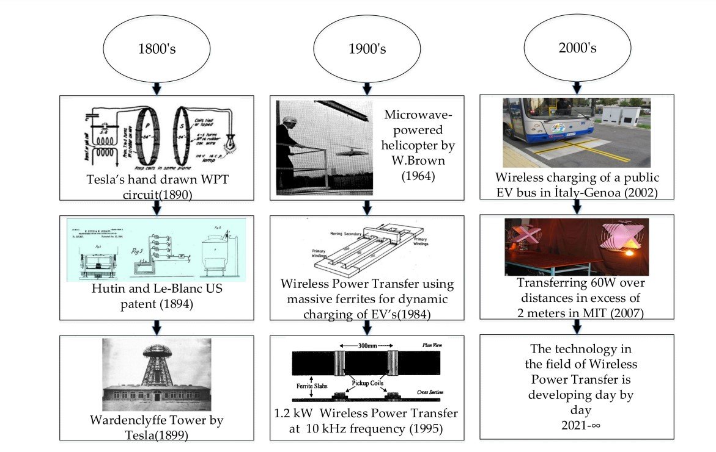

Figure 1. History of evolution of WPT

In the late 1800s, only a few studies had been conducted aside from Tesla’s discoveries. One of these studies was a patent registered by Hutin and Le-Blanc in 1894 [11], which was the first known idea for energizing Electric Vehicles wirelessly. With the end of the war period in the world, studies began to be published at the end of the 1900s. In the early 2000s, the idea of wirelessly charging electric vehicles was brought up in New Zealand. However, one of the first applications of this idea was carried out in 2002 in Genoa, Italy, in the electric bus project that charged busses wirelessly at the bus stop, as shown in Figure 2

**1.2** **Fundamentals of WPT system:**

the base principles on which modern WPT transfer systems are built, including a derivation of mutual inductance and coupling factor. A detailed explanation of reflection is included to support the basic power transfer and efficiency equations presented. This section illustrates key principles so as to supply a better context for the challenges faced and the breakthroughs achieved in WPT.

Overall Systems Configuration: WPT systems that make use of the inductive coupling method. Inductively coupled power transfer (ICPT) systems use the generated magnetic field from an inductor subject to a change in current as a means for transferring power wirelessly. A typical WPT system consists of a primary and secondary side coupled by inductors.

Mutual Inductance and Coupling Factor: The operating principle of ICPT is like that of a transformer in several aspects. The significant divergence is the lack of a fully formed ferrite core. In the case of ICPT, there is a significant air gap present between the primary and secondary windings.

Reflection: The nature of the system is such that as the primary causes an induced current in the secondary, the secondary also has an opposing effect on the primary.

Power Transfer and Efficiency: The power transfer from the primary to the secondary is then stated as the real part of the reflected resistance multiplied by the square of the primary current

P = (ReZr)I2

The efficiency of the system is expressed in an equivalent manner as a voltage divider over both the primary and secondary.

**1.3 Wireless energy transfer methods:**

Wireless power transfer methods encompass technologies such as Laser, photoelectric, radio waves (RF), microwaves, inductive coupling and magnetic resonance coupling. These technologies can be broadly categorized based on underlying mechanism, transmission range, and power rating. Based on the power transfer distance wireless energy transfer methods can be categorized into two types; near field and far field. If transfer distance is longer than the wavelength of electromagnetic wave, it is categorized in to far field technique. Laser, photoelectric, RF, microwave can be considered as far field energy transfer methods. Inductive coupling and magnetic resonance coupling based methods are regarded as near field approaches. Even though far field techniques have transmission range up to several kilometers, they suffer from the trade-off between directionality and efficiency. Frequency range of far field approaches are typically very high (GHz range) compared to near field (kHz– MHz). Inductively coupled near field approaches can be used to transmit high power efficiently in very near range (up to several centimeters). Efficiency of such systems deteriorates exponentially with the distance. The non-radiative WPT system demonstrated in 2007 by MIT based on magnetic resonance coupling can be used in mid-range application with an acceptable efficiency.

**1.4 Fundamentals of IPT system:**

In this section, different types of WPT systems, basic features and working principles are explained. WPT systems can be grouped under three main headings in which power transfer can take place by magnetic coupling, capacitive coupling and microwave propagation. Microwaves are applications where power transfer occurs with low efficiency by using high frequencies over long distances. For short-distance power transfer, Inductive and Capacitive Power Transfer (CPT) systems are the most popular used systems. Capacitive Power Transfer has some limitations on the power levels and the transfer distance since it is based on a confined electric field distribution between two conductive plates. Inductive Power Transfer (IPT) systems are the most frequently used and well-known power transmission systems that take advantage of magnetic flux distribution, applicable to all ranges of power and have considerably longer transfer distances than CPT systems. IPT systems are divided into two main groups according to the short and long distance between the coils. Due to the large distance between the coils in loosely coupled systems, the amount of leakage flux is high, and this is why it is named as such. Especially electric vehicle charging applications are considered in this group. In tightly coupled systems, there is a small gap between the coils, and the leakage fluxes are reduced and coupling is increased by using the core.

**1.5 Case study on dynamic charging:**

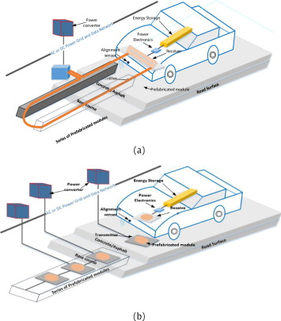

Fig.2 Dynamic Charging

In order to improve the two areas of range and sufficient volume of battery storage, dynamic mode of operation of the WCS for EVs has been researched This method allows charging of battery storage devices while the vehicle is in motion.

The vehicle requires less volume of expensive battery storage and the range of transportation is increased

As shown in figures, the primary coils are embedded into the road concrete at a certain distance with high voltage, high frequency AC source and compensation circuits to the micro grid and/or RES.

**1.6 Properties of WPT systems:**

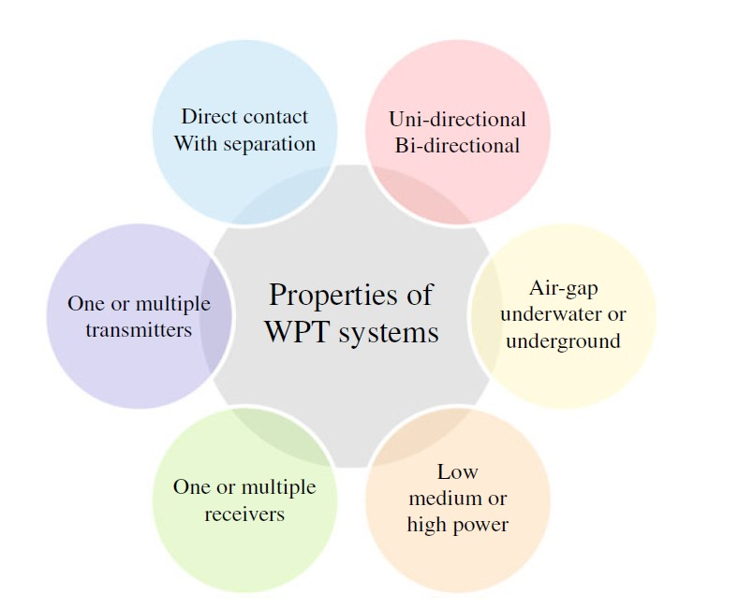

Fig.3 Main features of WPT systems

• **Transferred power**. WPT systems comprise applications for transmitting low power (up to 1 kW), medium power (1–100 kW) and high power (more than 100kW). The power requirement of the application greatly impacts on the systemdesign. Thus, for low power applications, efficiency is not as crucial as in other kinds of systems. Instead, transferring the maximum power possible is usually the primary aim of low-power applications.

• **Uni-directional or bi-directional** power transfer. According to this criterion, we can differentiate between WPT systems where the power transfer is always originated by a fixed element where a source is connected. This scheme corresponds to a uni-directional WPT. Alternatively, there are bi-directional systems where the load (a battery or a capacitor) occasionally provides energy to the source.

• **Gap**. This term refers to the distance between the energy transmitter and the receiver. Although all WPT systems avoid cables between these two components, in some applications there must be

a contact between them. This is the case with power mats. Alternatively, in some applications the transmitter and the receiver are separated by several centimetres or even meters.

• **Capacity to operate with intermediate objects** in the gap between the power transmitter and the receiver. Due to the wavelength, some technologies cannot operate with intermediate objects, others suffer from a relevant degradation under the presence of these elements, whereas in other technologies the impact is not noticeable.

• **Number of transmitters**. The most simple topology for a WPT system consists of one power transmitter and one power receiver. In order to extend the WPT spatial operability, several transmitters can be deployed in a region in order to transfer power to a load. In this case, more than one transmitter can be activated simultaneously considering their power availability and the efficiency of the power transfer (e.g. their power resources when derived from renewable energy sources). On the other hand, the role of transferring power can be executed by a different transmitter in a different time interval. This could be appropriate for mobile loads.

• **Number of receivers**. Although the usual topology for WPT systems considers just one receiver, there are some configurations designed to support multiple loads. Thus, it is possible that multiple receivers can benefit from the power generated by one transmitter.

• **Stationary/Mobile receiver**. In some applications, WPT must be able to handle the receiver being placed in a random position before the charge starts. This is the case for dynamic EV wireless charging.

• **Medium**. Although most current WPT products operate with an air gap between the power transmitter and the receiver, this technology can also be applied in other mediums such as water, ground or biological tissue. The medium clearly impacts on the efficiency as it is responsible for the power transmission losses. For instance, the study carried out in examined how the efficiency of the underwater WPT system is up to 5% lower than an air-gap system.

**1.7 Benefits of WPT:**

Despite the electrical and environmental benefits of EVs, drivers are still reluctant to use them as they believe this mode of transportation could reduce their autonomy. Thus, new convenient and user-friendly methods are needed to promote the increased use of EVs. In this context, WPT is a promising technology for this form of transportation. The main advantages that WPT can offer EVs are:

• Autonomous operation. The charge/discharge can be accomplished without the driver’s intervention. This autonomy is of particular interest for Vehicle-to-Grid (V2G) tasks, where the driver can participate in the electrical market without the need for any manual configuration from the user.

• Safer charge. As the driver is not required to use an electrical conductor, there is no risk of being in contact with a high electrical current. In addition, this energy transfer is safe in adverse weather conditions such as snow or rain.

• Dynamic charge. WPT extends the situations in which the EV may be charged so that it can be charged while moving or stationary for a short period. If this kind of charge becomes widespread, it will mean that the battery of the EVs can be smaller and, consequently, the vehicle will use cheaper electrical equipment. These advantages are relevant for all types of EVs, including cars, bicycles, buses, trains, boats and drones.

**1.8 Charging Modes in EVs:**

the charging modes deal with the battery as a unity which can receive a current and/or voltage

that is distributed internally by the BMS. The batteries can be charged in different ways. In this context, Society of Automotive Engineers (SAE) defines the following three charging levels in its Standard J1772:

Level 1. It provides charging through an AC plug at 120 V, which corresponds to a standard household plug. Thus, it does not require prior installation of any specific electrical equipment to charge the vehicle.

Level 2. Charging is achieved through an AC plug at 240 V and 40 A.

Level 3. In contrast to previous levels, here the charging process is performed using DC current instead of AC current. The output voltage is 480 V. the Commission identifies four modes:

• **Mode 1**. This provides AC charging with a maximum voltage of 250 V and a maximum

current of 16 A. This restricts the maximum power to 3.7 kW. A conventional household plug can support this connection. Due to overheating, it should not be used for long periods.

• **Mode 2**. Like mode 1, this is supported by a conventional plug but the cable incorporates a protection system. The protection is intended to check the power of the charge/discharge and to incorporate a communication scheme. The maximum current allowed in this mode is 32 A. The connection of the plug to the mains is Schuko whereas in the vehicle it is typically Mennekes.

• **Mode 3.** In contrast to the previous modes, this mode requires a specific installation connected to the grid. This system, which is referred to as wall box, implements the control and protection functionalities. In addition, this mode incorporates an active communication channel between the charging point and the car. Considering the implementation of the control systems, it is the most appropriate equipment to install for smart grids.

• **Mode 4**. This provides a charge to the vehicle in a DC power transfer. A wall box connected to the grid transforms Thea power to DC. This system also incorporates the protection and control mechanisms. It is especially intended for fast charging, with a maximum current of 400 A and a maximum power of 240 kW. Due to the particular features of the wall box, it is an expensive item of equipment.

**1.9 Literature survey:**

|  |  |  |  |
| --- | --- | --- | --- |
| **SI NO** | **Title of the Paper** | **Authors** | **Summary** |
| 1 | Inductive Power Transfer for Electric Vehicle Charging Applications: A Comprehensive Review | Emrulla Aydin Mehmet Timur Aydemir, Ahmet Aksoz, Mohamed El Baghdadi and Omar Hegazy | * the coil design, operating frequency selection, efficiency values and the preferred compensation topologies in the literature have been discussed * The control section gives the common charging control techniques and focuses on the constant current-constant voltage (CC-CV) approach, which is usually used for EV battery chargers. |
| 2 | Wireless Power Transfer Systems for Electric Vehicle Battery Charging with a Focus on Inductive Coupling | Iman Okasili, Ahmad Elkhateb | * explain the technology, its modern advancements, and its importance. * article classifies, describes, and critically compares different compensation schemes, converter topologies and coil structures of wireless power transfer systems for electric vehicle battery charging, focusing on inductive power transfer |
| 3 | Wireless Power Transfer for Electric Vehicle Applications | Siqi Li, Chunting Chris Mi | * By introducing WPT in EVs, the obstacles of charging time, range, and cost can be easily mitigated * Battery technology is no longer relevant in the mass market penetration of EVs. |
| 4 | Wireless Power transfer technologies for EV battery charging – A state of the art | D kishan, P. Srinivasa rao nayak | * presents a state of the art on different wireless power transfer (WPT) techniques for electric vehicle (EV) battery charging. * the limitations and challenges associated with the WPT techniques are explored |

1. **PROBLEM FORMULATION**

Wireless Power Transfer (WPT) technology can transfer electrical energy from a transmitter to a receiver wirelessly. Due to its many advantages, WPT technology is a more adequate and suitable solution for many industrial applications compared to the power transfer by wires. Using WPT technology will reduce the annoyance of wires, improve the power transfer mechanisms. Recently, the WPT gain enormous attention to charging the on-board batteries of the Electric Vehicle (EV). So it is necessary to charge the Electric Vehicles in such a manner that provides reliability to users and it should user friendly

1. **OBJEVTIVES**

* To build a WPT system for EV battery charging
* To Implement the Power converters for the wpt
* To Wirelessly transfer the Power from Sending side to receiving side
* To Check the State of Charging of the Battery

1. **METHODOLOGY**

Fig 4**.** Mechanism of the inductive power transfer

**COMPONENTS**

* AC Voltage source.
* Source rectifier circuit.
* High frequency Inverter circuit.
* Compensation network.
* Mutual Inductor.
* Vehicle Rectifier circuit.
* Li-ion Battery.

**Power electronics converter:**

In a WPT system, the function of the primary side power electronics converter is to generate a high frequency current in the sending coil. To increase the switching frequency and efficiency, usually a resonant topology is adopted. At the secondary side, a rectifier is adopted to convert the high frequency AC current to DC current. Depending on whether a secondary side control is needed, an additional converter may be employed. The primary side converter may be a voltage or a current source converter. As a bulky inductor is needed for the current source converter, the most common choice at the primary side is a full bridge voltage source resonant converter

**Mutual Inductor:**

In order to transfer power wirelessly, there are at least two magnetic couplers in a WPT system. One is at the sending side, named primary coupler. The other is at the receiving side, named pick-up coupler. Depending on the application scenarios, the magnetic coupler in a WPT for an EV could be either a pad or a track form. For higher efficiency, it is important to have high coupling coefficient *k* and quality factor *Q*.

**Compensation network:**

In a WPT system, the pads are loosely coupled with a large leakage inductance. it is required to use a compensation network to reduce the VA rating in the coil and power supply. In early inductive charging designs, the compensation is set on primary or secondary side only compensation at both the primary and secondary side is recommended to have a more flexible and advanced characteristics. To compensate a leakage inductance, the simplest way is to add a capacitor at each side. there are four basic compensation topologies, which are series-series (SS), series-parallel (SP), parallel-parallel (PP), parallel-series (PS)

### **Li-ion Battery:**

### Lithium-ion batteries are currently used in most portable consumer electronics such as cell phones and laptops because of their high energy per unit mass relative to other electrical energy storage systems. They also have a high power-to-weight ratio, high energy efficiency, good high-temperature performance, and low self-discharge. Most components of lithium-ion batteries can be recycled, but the cost of material recovery remains a challenge for the industry. The U.S. Department of Energy is also supporting the Lithium-Ion Battery Recycling Prize to develop and demonstrate profitable solutions for collecting, sorting, storing, and transporting spent and discarded lithium-ion batteries for eventual recycling and materials recovery. Most of today's all-electric vehicles and PHEVs use lithium-ion batteries, though the exact chemistry often varies from that of consumer electronics batteries. Research and development are ongoing to reduce their relatively high cost, extend their useful life, and address safety concerns in regard to overheating

Fig 5. MATLAB simulated connection

**Rectifier Circuit:**

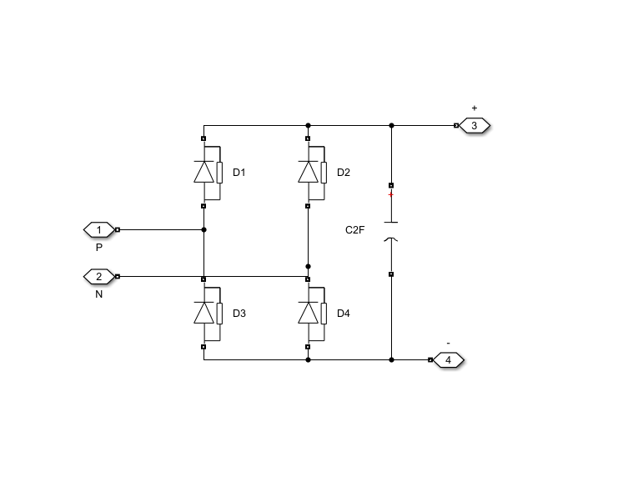

Fig 6. Rectifier circuit

* Here Diodes are employed for the Rectifiers which converts AC to DC

**Inverter Circuit:**

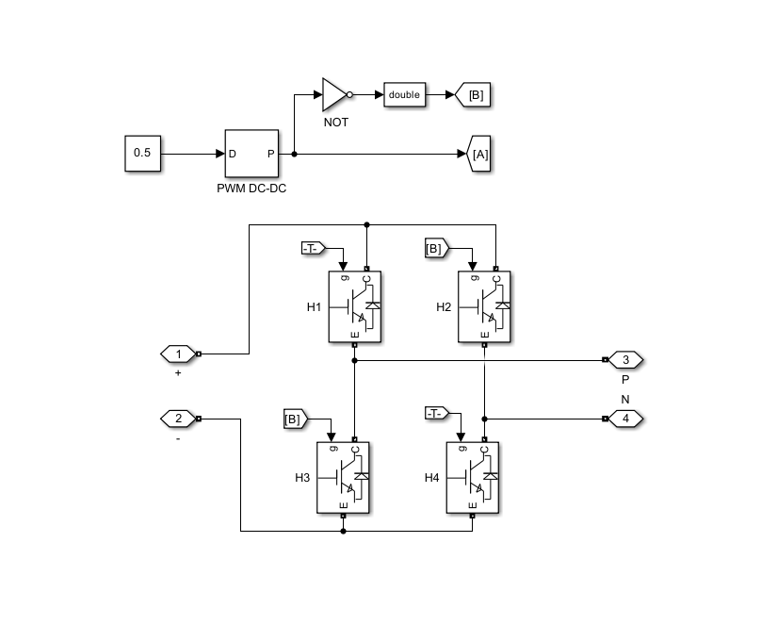

Fig 7. Inverter circuit

* IGBT power modules are needed to convert electricity from one form to another so that the electricity can be more conveniently and safely used by all the digital devices that make up our modern lives.
* Power modules become hot due to the heat loss in the conversion process and in some cases the losses are as great as 5%. For instance, in an electric vehicle the losses may be as high as 10-15% which in turn impacts the range and performance of the vehicle.

The main advantages of IGBT:

* It has a very low on-state voltage drop due to conductivity modulation and has superior on-state current density. So smaller chip size is possible and the cost can be reduced.
* Low driving power and a simple drive circuit due to the input MOS gate structure. It can be easily controlled as compared to current controlled devices (thyristor, BJT) in high voltage and high current applications.
* Wide SOA. It has superior current conduction capability compared with the bipolar transistor. It also has excellent forward and reverse blocking capabilities

### The State of Charge

The state of charge (SOC) is a measurement of the amount of energy available in a battery at a specific point in time expressed as a percentage. For example, the SOC reading for a computer might read 95% full or 10% full. The SOC provides the user with information of how much longer the battery can perform before it needs to be charged or replaced. Understanding the state of charge is important because understanding the remaining capacity of a batter can help make a control strategy.

The accurate estimation of the SOC involves many nonlinear effects such as open circuit voltage (OCV), instantaneous current, charge and discharge rate, ambient temperature, battery temperature, parking time, self-discharge rate, Coulomb efficiency, resistance characteristics, SOC initial value, depth of discharge (DOD), etc. These factors are affected by different materials and processes, and they also interact with each other, so the SOC calculation of power batteries is complex and difficult, which is a challenge that has not been overcome for many years. The dc-dc converter control typically also involves a cascaded control loop, but, in this case, the inner loop regulates the current fed to the battery through the charging connector, while the outer loop regulates the EV BMS commonly estimates battery SoC using Coulomb counting or model-based estimation methods

We obtained the state of charge by coulomb counting method using the formula,

(𝑄𝑐− 𝐼 )

*Where ,*

𝑆𝑂𝐶 = 3600 ∗ 100

𝑄𝑐

Qc = Battery capacity. I = Integrated current.

# RESULTS

* + From the Fig 6. We can analyse that the battery is successfully charging. With the charging time the percentage of charging increases linearly

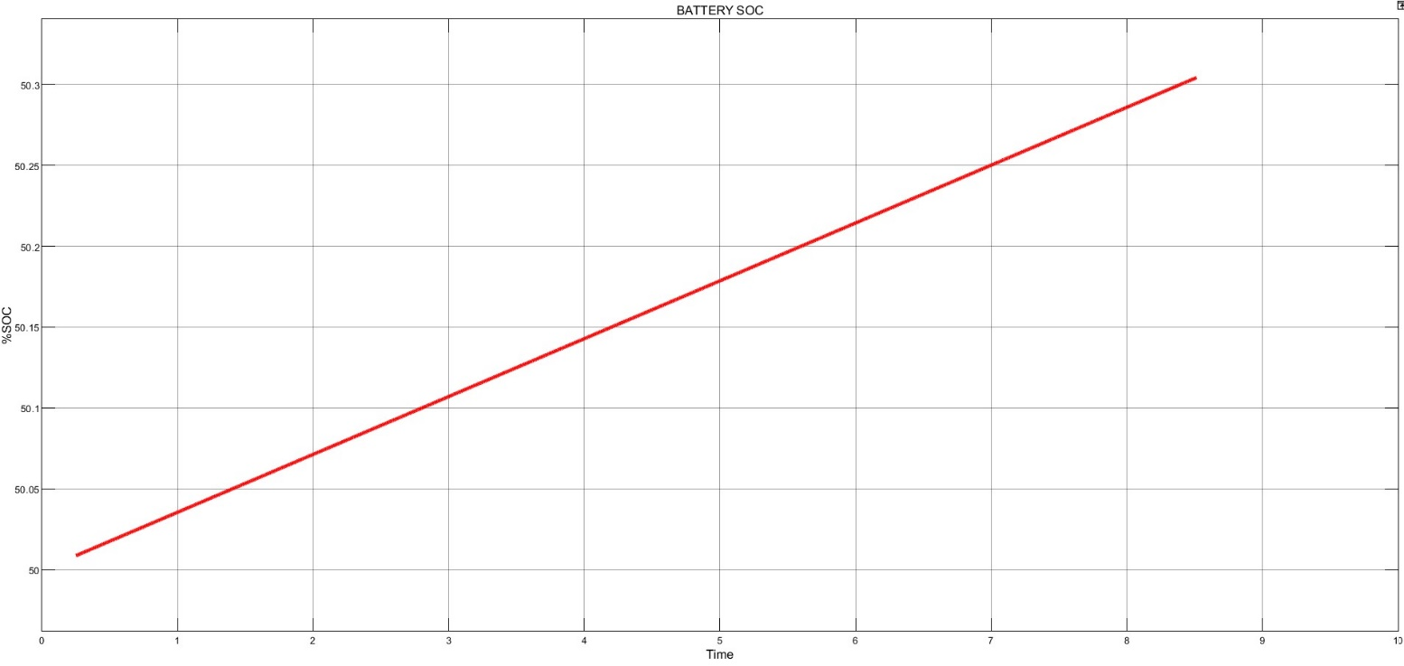

Fig.8 State of Charging

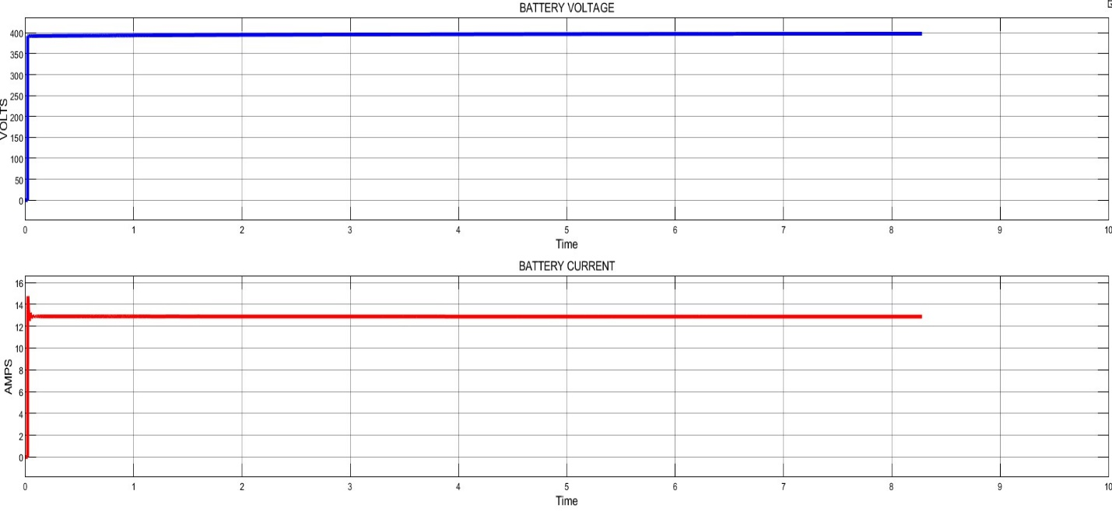

Fig 9 Battery voltage and battery current

## 5.1 CONCLUSION:

In this article, a comprehensive review of the WPT systems for electric battery charging focusing on inductive power transfer is presented. It is clear that vehicle electrification is unavoidable due to environment and energy related issues. WPT for EV battery charging offers an ergonomic means of tackling the range and charge time anxieties surrounding EVs. Every year research pushes the technology further, and with the emergence of commercial units, the technology is about to gain its foothold. Whilst the advancements in recent years have been significant. There are still important challenges to overcome Wireless charging will provide many benefits compared to wired charging. In particular, when the roads are electrified with wireless charging capability, it will provide the foundation for mass market penetration for EV regardless of battery technology. With technology development, wireless charging of EV can be brought to fruition. Further studies in topology, control, inverter design, and human safety are still needed in the near term.

# 5.2 References:

|  |  |
| --- | --- |
| [1] | Aydin, Emrullah & Aydemir, Mehmet & Aksöz, Ahmet & El Baghdadi, Mohamed & Hegazy, Omar. (2022). Inductive Power Transfer for Electric Vehicle Charging Applications: A Comprehensive Review. Energies. 15. 4962. 10.3390/en15144962. |
| [2] | Okasili, I.; Elkhateb, A.; Littler, T. A Review of Wireless Power Transfer Systems for Electric Vehicle Battery Charging with a Focus on Inductive Coupling. Electronics **2022**, 11, 1355. https://doi.org/10.3390/electronics11091355 |
| [3] | S. Li and C. C. Mi, "Wireless Power Transfer for Electric Vehicle Applications," in IEEE Journal of Emerging and Selected Topics in Power Electronics, vol. 3, no. 1, pp. 4-17, March 2015, doi: 10.1109/JESTPE.2014.2319453. |
| [4] | D. Kishan and P. S. R. Nayak, "Wireless power transfer technologies for electric vehicle battery charging — A state of the art," 2016 International Conference on Signal Processing, Communication, Power and Embedded System (SCOPES), Paralakhemundi, India, 2016, pp. 2069-2073, doi: 10.1109/SCOPES.2016.7955812. |
| [5] | Ahmed, A. & Khalifa, Othman. (2020). Wireless power transfer for electric vehicle charging. AIP Conference Proceedings. 2306. 020026. 10.1063/5.0032383. |